RR Teil I, pp. 107-123

Research Facilities

The Behavioral and Social Sciences Laboratory provides a powerful and efficient infrastructure for conducting research in the behavioral and social sciences. The Jacobs Center operates the laboratory together with the School of Humanities and Social Sciences. Since the laboratory provides over 1200 m² of research space, it is Europe's largest laboratory of its kind.
The laboratory forms an essential base for the research activities of the Center:
Its measurement sets for electrodermal and cardiovascular activity, the eye-tracking equipment and the ergospirometry allow the examination of brain functions and age- related changes in physical and mental performance. Group and single rooms equipped with one-way mirrors, cameras and presentation facilities enable to conduct interviews, behavior video observation and telephone surveys which are important for our researchers who explore decision making and learning behavior. Altogether, 77 trial areas can be used, which include a senso-lab (to test touch perception, motor-lab (to test fine motor skills), computer-lab (to test intelligence) and human performance lab (to test the plasticity of the brain).

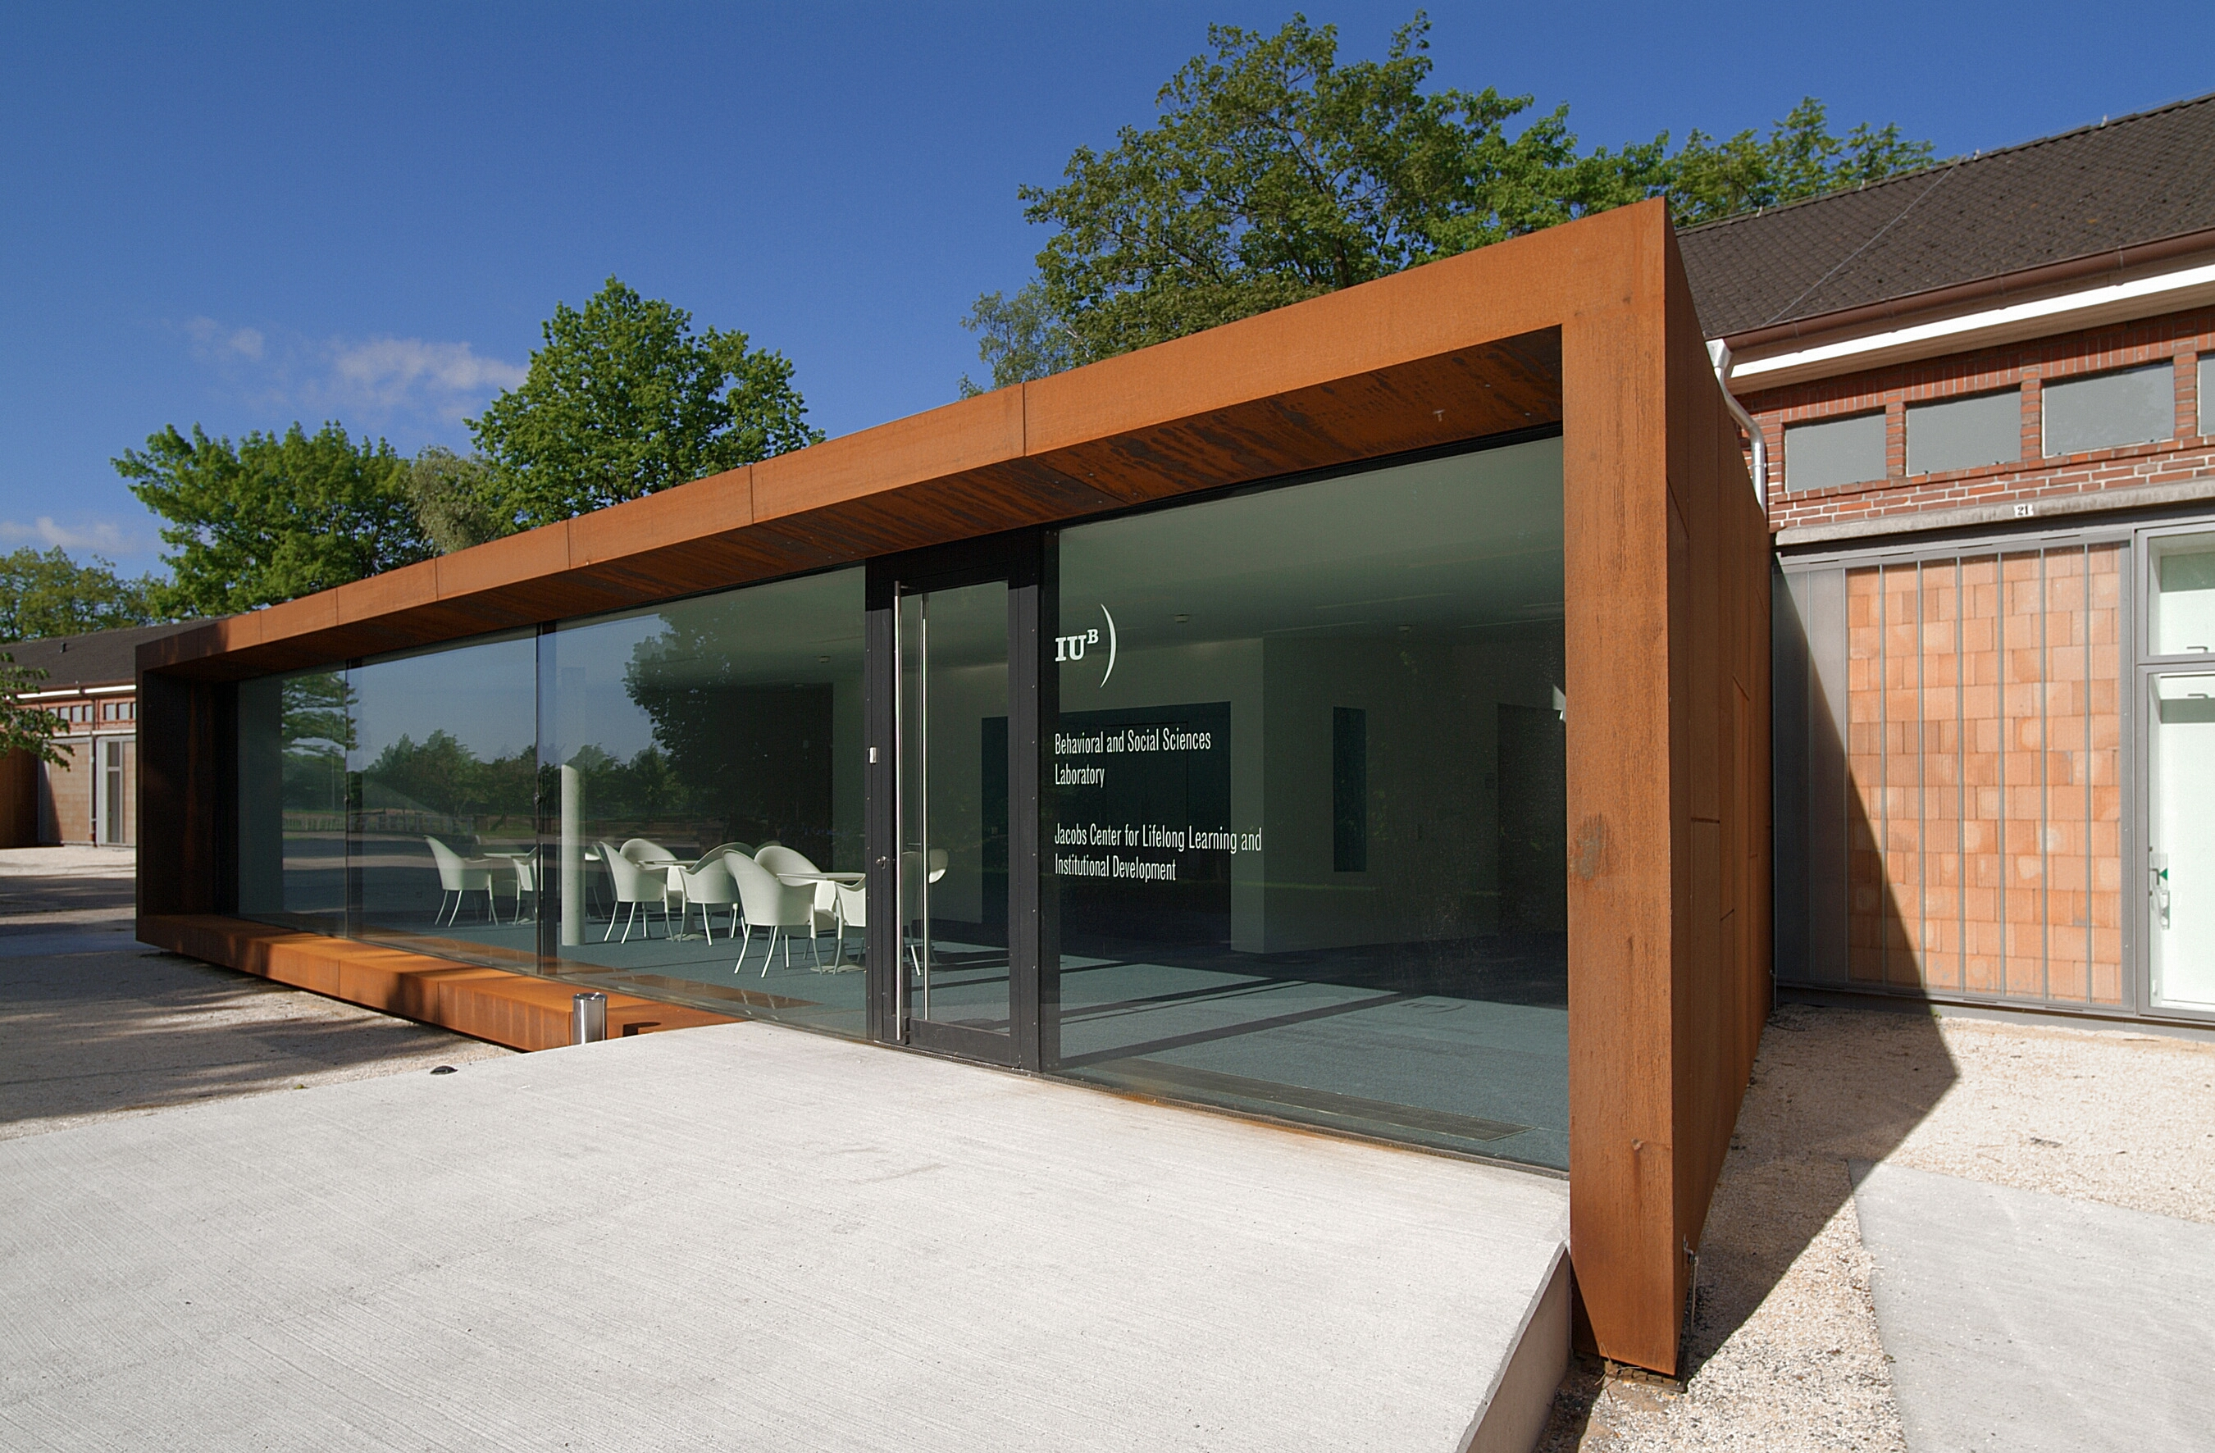

Grants
- Bremen International Graduate School of the Social Sciences ^{BI}GSSS”, Project in cooperation with the University Bremen and the SHSS (Co-PI: U. M. Staudinger), German Excellence Initiative, DFG, (2008-2011).

- BMBF (PI: Staudinger et al.). Joint research project: Effects of Matches/Mismatches between Aspects of Human and Social Capital, Corporate Strategy and Work Organization on the Physical and Mental Well-Being of Employees, (2007 – 2010).

- Emmy Noether Research Group, part I (KU 1401/4-1), part II (KU 1401/4-2), and part III (KU 1401/4-3) funded by the DFG, (PI: B.M. Kudielka): Stress and burnout - Integration of work psychological and psychobiological research methods for the assessment of differential stress patterns in chronic work stress (2004 – 2009).

- IRTG International Research Training Group (‘Internationales Graduiertenkolleg’) of Trier (Germany) and Leiden (The Netherlands) (GRH 1389/1); funded by the DFG (B.M. Kudielka was one out of 11 Co-Applicants (German part)): Psychoneuroendocrinology of stress: from molecules and genes to affect and cognition (2006 – 2010).

- Jacobs Center on Lifelong Learning and Institutional Development (PI: U. M.Staudinger), Jacobs Foundation (2003-2009).

- Leopoldina (PI: U. M. Staudinger) Joint Academy Group: Aging in Germany
(2006-2009).

- Robert Bosch Foundation (PIs: C. Voelcker-Rehage, B. Godde, U. M. Staudinger): Old Age on the Move (2006-2009).

- Volkswagen Foundation (PIs: K. Schömann, U. M. Staudinger, B. Godde) Job Mobility and Developmental Outcomes (2008-2011).

- Volkswagen Foundation (PI: C. Stamov Roßnagel): Older workers’ cognitive innovation resources (2008-2011).
- Volkswagen Foundation Initiative „Gesellschaftliche und kulturelle Herausforderungen Innovationsprozesse in Wirtschaft und Gesellschaft“ (PIs: S. Voelpel and G. Van der Vegt,): Proposal: The Effects of the Aging Workforce on the Innovation Process: A Large-Scale Study of Technology Intensive Companies, (2007-2010).

- Selected Knowledge Transfer Activities

- Executive Teaching for AutoUni in Wolfsburg by K. Schömann.
- Executive Teaching for Schneider Electric, ThyssenKrupp AG, Volkswagen AG, by C. Stamov Roßnagel.
- Executive Teaching for Next Generation Leadership Programme in collaboration with TiasNimbas Business School (Tilburg, NL) (C. Stamov Roßnagel, Course-Director).
- Executive Teaching for Leadership Academy, Lower Saxony Penitentiary Service, German Society for Personnel Management (DGFP) by C. Stamov Roßnagel.
- Consulting Project (PI: K. Schömann): Evaluation of company-wide occupational health and safety trainings ENO/RNO Bremen.
- ADECCO Institute (PI: K. Schömann and C. Rossnagel): Compendium on Lifelong Learning - Qualification Needs in the OECD – Analysis, Implementation and Policy Recommendations.
- WISE Demographie Netzwerk (Companies: Deutsche Bahn, Deutsche Bank, EnBW, Lonza, Otto Group, VW) (PIs: S. Voelpel, C. Stamov Roßnagel),
(2007-2010).
- Projekt Innovationsmanagement (Companies: EADS Astrium, KAEFER, Meyer Werft, Rheinmetall) (PI: S. Voelpel), (2007).
- Consulting Project (PI: C. Stamov Roßnagel): An age-differentiated view on work and learning motivation at HeidelbergCement. HeidelbergCement.
- Consulting Project (PI: M. Schulz, C. Stamov Roßnagel): Evaluation of a learning competency training. EnBW.

.
- Awards and Honors Received by Members of the Jacobs Center

Awards and Honors Received by Ben Godde / Claudia Voelcker-Rehage
2007: Research Award from Sparkasse Bremen and Unifreunde Bremen to Ben Godde & Claudia Voelcker-Rehage for cooperative projects between University Bremen and Jacobs University, together with Ekkehard Küstermann, Peter Erhard (both University Bremen), and Markus Ebke (Hospital Bremen-Center).

Awards and Honors Received by Brigitte Kudielka/ Silja Bellingrath
2008: Biological Psychology Author Award for the Top cited Paper in 2006 and 2007 to Brigitte M. Kudielka and Clemens Kirschbaum for the paper “Sex differences in HPA axis responses to stress: a review”, Volume 69/1 (2005).

2008: Charlotte- und Karl-Bühler-Award 2008 of the German Society for Psychology (DGPs) to Brigitte M. Kudielka (endowed with €1000).

2008: Young Investigator Award 2008 of the International Society of Psychoneuroendocrinology (ISPNE), awarded to Silja Bellingrath, doctoral student in the Emmy-Noether Project (Principal Investigator: Brigitte M. Kudielka).

2007: Scholar Award to Silja Bellingrath, doctoral student in the Emmy-Noether Project (Principal Investigator: Brigitte M. Kudielka) of the American Psychosomatic Society (APS)

2007: Press Release Invitation for abstract: ‘Dysregulations of the HPA-axis and increased allostatic load in job-related chronic stress: A link to burnout and exhaustion in school teachers?’ authored by Bellingrath S., Hellhammer D.H., Kudielka B.M. at the 2007 Annual Meeting of the American Psychosomatic Society (APS).

Awards and Honors Received by Ursula M. Staudinger

Since 2008: President, since 2006 Vice President of the German Psychological Society DGPs

Since 2007: Vice President of the National Academy of Sciences Leopoldina
Awards and Honors Received by Sven Voelpel
2007: Nomination for the SMS Best Conference Paper for Practice Implications Award. [Zhao, C.L., Han, Z. & Voelpel, S. (2007). Meeting the environmental challenges: Strategies against counterfeiters in China. 27th SMS Annual International Conference, October 14-17, 2007, San Diego, California, USA].
2007: Sven Voelpel: Nr. 5 in most read Organization Studies articles [Nonaka, I., von Krogh, G., & Voelpel, S. (2006). Organizational knowledge creation theory: Evolutionary paths and future advances. Organization Studies, 27(8), 1179-1208.]
2007: Sven Voepel: Long Range Planning: Editor's 10 Excellent Articles List, 2007 [Beer, M., Voelpel, S., Leibold, M., & Tekie, E. (2005). Strategic management as organizational learning: Developing fit and alignment through a disciplined process. Long Range Planning, 38(5), 445-465.]

PhD Degrees

2007
Otto, Siegmar - with distinction: “Meaning and Use of the Terms ‘Sustainability” and ‘sustainable Development’- an empirical study”.
Dissertation Committee: Prof. Dr. Clemens Schwender (Supervisor, Jacobs-University), Prof. Dr. Sven Voelpel (Jacobs University), Prof. Dr. Alfons Matheis (FH Trier), Prof. Dr. Werner Schulz (University of Hohenheim).

2008
Fasang, Anette - with distinction: “Family Biographies and Retirement Processes - A comparative analysis of West Germany and the United Kingdom”.
Dissertation Committee: Prof. Dr. Klaus Schömann (Supervisor, Jacobs-University), Prof. Dr. Hilke Brockmann (Jacobs University), Prof. Dr. Karl-Ulrich Mayer (Yale University), Prof. Dr. Silke Aisenbrey (Yeshiva University).

Mühlig Versen, Andrea: “Personality Development in Old Age- A Quasi-Experimental, Longitudinal Field Study”.
Dissertation Committee: Prof. Dr. Ursula M. Staudinger (Supervisor, Jacobs University), Prof. Dr. Margit Schreier (Jacobs University), Prof. Dr. Hans-Werner Wahl (University of Heidelberg).

Streb, Christoph: “Empirical Research on Aging Workforce Management: Secondary Data, Grounded Theory, and Case Study Findings with Particular Consideration of the Automobile Industry”.
Dissertation Committee: Prof. Dr. Sven Voelpel (Supervisor, Jacobs University), Prof. Dr. Marius Leibold (Stellenbosch University), Prof. Dr. Adalbert FX Wilhelm (Jacobs University), Prof. Dr. Horst-Erich Rikeit (University of Bremen).

Faculty

Dr. Godde, Benjamin Professor of Human Performance and Neuroscience
Dr. Kaase, Max Professor of Political Science (since 09/2007)
Dr. Kudielka, Brigitte Professor of Health Psychology (since 05/2008)
Dr. Schömann, Klaus Professor of Sociology
Dr. Stamov Roßnagel, Christian Professor of Organizational Behavior
Dr. Staudinger, Ursula M. Professor of Psychology, Dean
Dr. Voelcker-Rehage, Claudia University Lecturer, Human Performance
Dr. Voelpel, Sven Professor of Business Administration

Graduate Students and Postdoctoral Fellows

Baron, Stefan Graduate Student (Sociology, since 04/2007).
Bellingrath, Silja Postdoctoral Fellow (Health Psychology, since
10/2008).
Biemann, Torsten Postdoctoral Fellow (Business Administration, since 09/2007).
Bittner, Jennifer Postdoctoral Fellow (Organizational Behavior,
since 12/2008).
Bowen, Catherine Graduate Student (Psychology, since 04/2007).
Dolge, Katja Graduate Student (Neuroscience, since 08/2008).
Eckhoff, Robert Graduate Student (Business Administration, since 10/2007).
Fasang, Anette Graduate Student (Sociology, until 08/2008).
Feuerhahn, Nicolas Graduate Student (Health Psychology, since 06/2008).
Geerdes, Sara-Izabella Graduate Student (Sociology).
Heidemeier, Heike Postdoctoral Fellow (Psychology).
Isichenko, Polina Graduate Student (Business Administration).
Kearney, Eric Postdoctoral Fellow (Business Administration, since 10/2007).
Korff, Jörg Graduate Student (Business Administration, since 08/2007).
Licklederer, Claudia Graduate Student (Business Administration, since 07/2008).
Mühlig-Versen, Andrea Graduate Student (Psychology, until 07/2008).
Noack, Martin Graduate Student (Psychology).
Noethen, Daniela Graduate Student (Business Administration, since 04/2007).
Oeberst, Andries Graduate Student (Psychology).
Otto, Siegmar Graduate Student (until 04/2007).
Panzer, Martina Graduate Student (Psychology).
Richter, David Graduate Student (Psychology).
Sauer, Anne Graduate Student (Business Administration, since 10/2008).
Schaffer, Stefan Graduate Student (Business Administration, since 11/2007).
Schelkes, Daniel Graduate Student (Sociology, since 04/2008).
Schulz, Melanie Graduate Student (Organizational Behavior).
Speckmann, Katharina Graduate Student (Business Administration, since 05/2008).
Tekie, Eden Graduate Student (Business Administration).
Trautmann, Mireille Postdoctoral Fellow (Neuroscience, since
12/2008).
Zhao, Chunli Graduate Student (Business Administration).

Where Have Our Researchers Gone?

Faculty

Kunzmann, Ute University of Leipzig
Renner, Britta University of Constance

Schwender, Clemens University of Management and Communication Potsdam (FH)

Postdoc
Han, Zheng University of St. Gallen

Kessler, Eva-Maria University of Heidelberg

PhD

Dörner, Jessica University of Trier
Fasang, Anette Yale University, Postdoctoral Fellow
Mickler, Charlotte Humboldt University Berlin
Mühlig-Versen, Andrea University of Bremen, Research Associate
Otto, Siegmar Institute for Ecological Economy Research, Berlin, Research Associate
Streb, Chris University of Groningen, Assistant Professor

Visiting Scholars at the Jacobs Center

Prof. Dr. Nicola Baumann (Department of Psychology, University of Trier, Presentation: “How do we grow? Personal growth through affect regulation”).

Prof. Dr. Hans-Peter Blossfeld (Holds the Chair of Sociology I and is the Director of the Staatsinstitut für Familienforschung at Bamberg University).

Prof. Dr. Andreas Diekmann (Professor of Sociology, ETH Zurich, Presentation: ‘Social Cooperation, Results from Experimental Game Theory’).

Dr. Werner Eichhorst (Institute for the Study of Labor (IZA), Bonn, Presentation: ‘From Transfers to Training’).

Prof. Dr. Michael Falkenstein (Leiter der Projektgruppe "Altern und ZNS-Veränderungen", Institut für Arbeitsphysiologie (IfADo), Technische Universität Dortmund).
Denis Gerstorf, Ph.D. (Assistant Professor of Human Development at the Department of Human Development and Family Studies, The Pennsylvania State University, State College(Held a lecture in July at Jacobs Center)).
Dr. Daniel Grühn (FPSE-Psychology, University of Geneva, Presentation: ‘The Positive and the Negative Side of Older Adults' Memory: Age-Related Differences in Remembering Emotional Information’).

Prof. Dr. Thomas M. Hess (Department of Psychology, North Carolina State University, NC, USA, Presentation: ‘A Social Cognitive Approach to Understanding Aging and Decision Making: Affective, Motivational, and Experiential Influences’).

Prof. Dr. Herbert Heuer (Leibniz Research Center for Working Environment and Human Factors, Institute for work physiology, University of Dortmund, Presentation: ‘Adaptation to Visuo-motor Rotations of Different Magnitude in Younger and Older Adults’).

Prof. Dr. Johannes Huinink (Professor für Soziologie mit Schwerpunkt „Theorie und Empirie der Sozialstruktur“ am Institut für empirische und angewandte Soziologie der Universität Bremen).

Prof. Dr. Michael Hüther (Honorary Professor at the European Business School, Director, Institut der deutschen Wirtschaft Köln, Presentation: ‘Intergenerational Justice and Economic Growth – A Challenge for Economic Policy’).

Prof. Dr. Jürgen Kocka (Chair for the History of the Industrial World at the Free University of Berlin, Presentation: ‘Chances and Challenges of Aging Societies’).

Prof. Dr. Gisela Labouvie-Vief (Professor of Social-Emotional Development, University of Geneva, Switzerland, Presentation: ‘Dynamic Emotion-Cognition Relations in Adulthood’).

Prof. Dr. Marius Leibold (Department of Business Management, Stellenbosch University, South Africa).

Prof. Dr. Pawel Lewicki (Professor of Psychology, Psychology Department, University of Tulsa).

Dr. Dr. Talat Mahmood (Social Science Research Center Berlin (WZB); Berlin, Germany).

Prof. Dr. Karl Ulrich Mayer (Professor of Sociology and Director of the Center for Research on Inequalities and the Life Course (CIQLE) at Yale University, Presentation: ‘New Directions in Life Course Research’).

Prof. Dr. Franz J. Neyer (Professor of Lifespan Development, University of Vechta, Presentation: ‘Personality Development and Relationship Development’).

Prof. Dr. Lars Nyberg (Professor of Neuroscience, Umeǻ University, Sweden, Presentation: ‘Memory and Executive Deficits in Relation to Fronto-Striatal Functioning’).

Prof. Dr. Ernst Poeppel (Vorstand des Instituts für Medizinische Psychologie (IMP) der LMU München. Geschäftsführender Vorstand des Humanwissenschaftlichen Zentrums (HWZ) der LMU München; Institute of Medical Psychology, LMU Munich, Presentation: ‘Fifty years and beyond: Too old to learn something new?’).

Nilam Ram, Ph.D. (Assistant Professor, Department of Human Development and Family Studies, The Pennsylvania State University, (Held a lecture in July at Jacobs Center)).

Prof. Dr. Patricia Reuter-Lorenz (Professor of Psychology, University of Michigan, Ann Arbor, Presentation: ‘Neuro-cognitive Aging and the Compensation Hypothesis’).

Prof. Dr. Ramón Rico (Department of Social Psychology and Methodology, Faculty of Psychology, Universidad Autónoma de Madrid).

Prof. Dr. Klaus Rothermund (Chair of General Psychology, Institut für Psychologie, Friedrich-Schiller-Universität Jena).

Prof. Dr. Georg Schreyögg (Professor of Organization and Leadership, Free University of Berlin, Presentation: ‘Characteristics and Relevance of Knowledge-Intensive Firms’).

Dr. Antje Stange (Visiting Scientist, Adult Development Lab, Georgia Institute of Technology, School of Psychology, Atlanta, Presentation: ‘Explaining Others’ Behavior: When do Old and Younger People differ in their Social Judgments?’).

Prof. Dr. Jürgen Wegge (Professor of Industrial and Organizational Psychology, Technical University of Dresden, Presentation: ‘The Aging Workforce: Problems and Chances with Respect to Effective Team Work’).

Prof. Dr. Reinhold Weiß (Deputy President and Head of Research of the Federal Institute for Vocational Education and Training (BIBB), Presentation: ‘From Formal Training to a New Learning Culture: Trends and Challenges of Lifelong Learning’).

Prof. Dr. Sherry L. Willis (Professor of Human Development, Pennsylvania State University, Presentation: ‘Midlife: Risks and Resources’).

Dr. Gerben S. Van der Vegt (Professor of Work and Organizational Psychology, Department of Management and Organization, University of Groningen, NL , Presentation: ‘When and Why does Power Asymmetry Affect Team Performance?’).

Prof. Dr. James W. Vaupel (Director, Max Planck International Research Network on Aging, Professor of Demography, Max Planck Institute for Demographic Research, Rostock, Presentation: ‘Remarkable Plasticity of Longevity – Policy Challenge of Population Aging’).
- JCLL Fact Sheets

Development of Grants

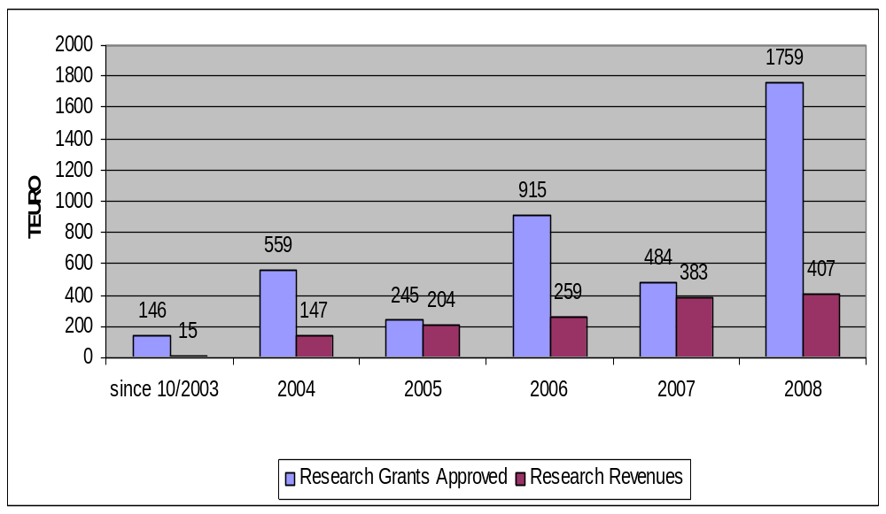

Figure 20: JCLL Revenues Research Grants 2003 – 2008

Development of Publications
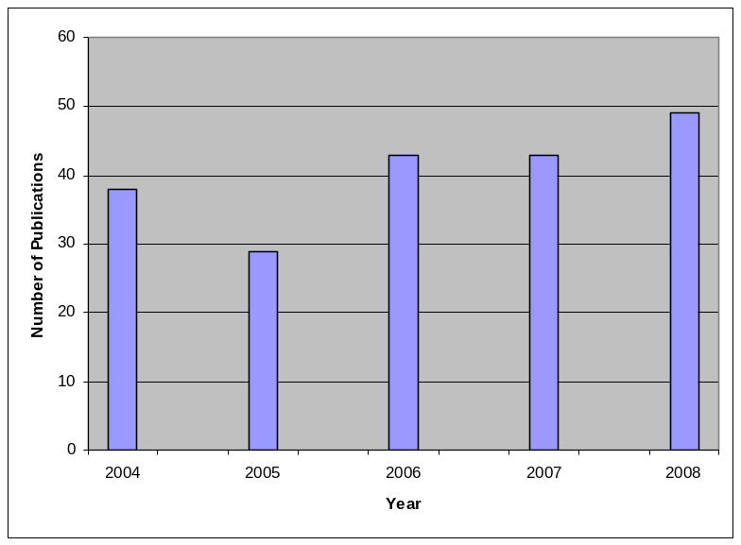

Figure 21: Number of peer-reviewed articles, chapter in handbooks/encyclopedias, chapters in edited volumes, monographs, edited volumes, articles in popular science and other kinds of publications
Development of Staff
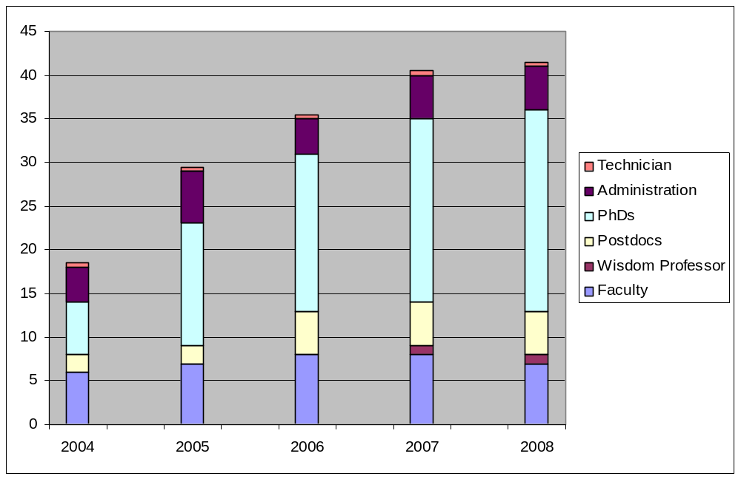

Figure 22: Development of Personnel at the JCLL

Impressum

Executive Editor
Prof. Dr. Ursula M. Staudinger
Dean, Jacobs Center on Lifelong Learning and Institutional Development

Production Editor and Editor
Dr. Krystin Zigan

Editors
Prof. Dr. Ben Godde (Human Performance and Neuroscience)
Prof. Dr. Brigitte Kudielka (Health Psychology)
Prof. Dr. Klaus Schömann (Sociology)
Prof. Dr. Christian Stamov Roßnagel (Organizational Behavior)
Prof. Dr. Ursula M. Staudinger (Psychology)
Dr. Claudia Voelcker-Rehage (Human Performance)
Prof. Dr. Sven Voelpel (Business Administration)

Cover Pictures: Department of Corporate Communications, Jacobs University Bremen

